CO2 AT1- SCENARIO BASED QUESTION :
1. A hospital information system stores different subclasses of Medical Record in one collection but must prevent unrelated
objects from being inserted. Propose a bounded generic class or method design. [Generic Bounds]
Scenario:
A hospital uses a Hospital Information System (HIS) to store different types of patient medical records. The system has various record types such as:
- PatientRecord – Stores patient details.
- LabReport – Stores blood test, urine test, and scan results.
- Prescription – Stores medicines prescribed by doctors.
All these record types are medical records, so the hospital wants to keep them in one common collection.
However, the system must not allow unrelated objects, such as Employee, Doctor, Vehicle, or Room, to be inserted into the medical record collection because they are not medical records.
To ensure this, Java Generic Bounds are used.
What are Generic Bounds?
A bounded generic restricts the type of objects that can be used with a generic class or method.
Syntax:
class ClassName<T extends ParentClass>
Here,
- T is the generic type.
- extends ParentClass means only the parent class and its subclasses are allowed.
If any unrelated class is used, Java gives a compile-time error.
This improves type safety.
Program:
import java.util.ArrayList;
// Parent class
class MedicalRecord {
String patientName;
MedicalRecord(String patientName) {
this.patientName = patientName;
}
public void display() {
System.out.println("Patient : " + patientName);
}
}
// Subclass 1
class PatientRecord extends MedicalRecord {
PatientRecord(String patientName) {
super(patientName);
}
public void display() {
System.out.println("Patient Record : " + patientName);
}
}
// Subclass 2
class LabReport extends MedicalRecord {
LabReport(String patientName) {
super(patientName);
}
public void display() {
System.out.println("Lab Report : " + patientName);
}
}
// Subclass 3
class Prescription extends MedicalRecord {
Prescription(String patientName) {
super(patientName);
}
public void display() {
System.out.println("Prescription : " + patientName);
}
}
// Unrelated class
class Employee {
String employeeName;
Employee(String employeeName) {
this.employeeName = employeeName;
}
}
// Generic class with bounded type
class RecordStore<T extends MedicalRecord> {
ArrayList<T> records = new ArrayList<>();
public void addRecord(T record) {
records.add(record);
}
public void showRecords() {
for(T record : records) {
record.display();
}
}
}
public class HospitalDemo {
public static void main(String[] args) {
RecordStore<MedicalRecord> hospital = new RecordStore<>();
hospital.addRecord(new PatientRecord("Rahul"));
hospital.addRecord(new LabReport("Priya"));
hospital.addRecord(new Prescription("Karthik"));
hospital.showRecords();
// Compile-time Error
// hospital.addRecord(new Employee("Ramesh"));
}
}

Output
Patient Record : Rahul
Lab Report : Priya
Prescription : Karthik

Output screenshot :
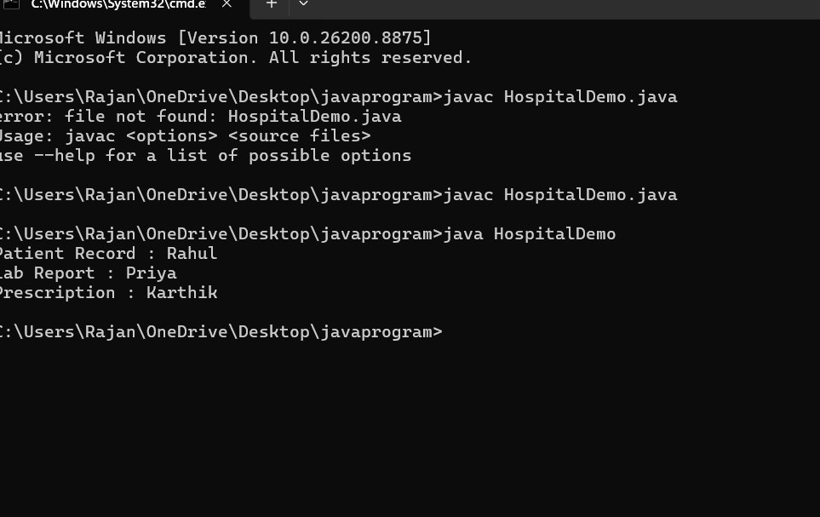
Step-by-Step Explanation
Step 1: Create the Parent Class
class MedicalRecord
This is the base class.
Every medical record in the hospital belongs to this class.
Example:
- Patient Record
- Lab Report
- Prescription
All inherit from MedicalRecord.

Step 2: Create Subclasses
class PatientRecord extends MedicalRecord
class LabReport extends MedicalRecord
class Prescription extends MedicalRecord
These classes inherit all properties of MedicalRecord.
Because of inheritance, they are valid medical records.

Step 3: Create an Unrelated Class
class Employee
Employee is not a medical record.
It has no relationship with MedicalRecord.
Therefore it should never be stored in the medical record collection.

Step 4: Use Generic Bounds
class RecordStore<T extends MedicalRecord>
This is the most important statement.
It means:
- T can be MedicalRecord.
- T can be PatientRecord.
- T can be LabReport.
- T can be Prescription.
But T cannot be Employee.

Step 5: Store Records
ArrayList<T> records = new ArrayList<>();
The ArrayList stores only objects of type T.
Since T extends MedicalRecord, only medical records are stored.

Step 6: Add Records
hospital.addRecord(new PatientRecord("Rahul"));
Allowed because PatientRecord extends MedicalRecord.
Similarly,
hospital.addRecord(new LabReport("Priya"));
Allowed.
hospital.addRecord(new Prescription("Karthik"));
Also allowed.

Step 7: Prevent Invalid Objects
If we write
hospital.addRecord(new Employee("Ramesh"));
Java produces a compile-time error because Employee does not extend MedicalRecord.
Error (conceptually):
The method addRecord(MedicalRecord)
is not applicable for Employee
Thus, unrelated objects are prevented from entering the collection.

Why Generic Bounds are Used?
Without generic bounds:
ArrayList<Object>
The list could store:
- PatientRecord ✅
- LabReport ✅
- Employee ❌
- Car ❌
- Laptop ❌
This is unsafe.
With bounded generics:
<T extends MedicalRecord>
Only:
- PatientRecord ✅
- LabReport ✅
- Prescription ✅
are allowed.
Everything else is rejected during compilation.

Advantages of Generic Bounds
- Type Safety: Only valid medical record objects can be stored.
- Compile-Time Error Detection: Prevents incorrect object insertion before the program runs.
- Code Reusability: The same generic class works with all subclasses of MedicalRecord.
- Maintainability: New medical record types (e.g., XRayReport) can be added easily by extending MedicalRecord.
- Reduced Runtime Errors: Invalid objects are caught during compilation rather than causing runtime problems.

Conclusion
In the hospital information system, the generic declaration:
class RecordStore<T extends MedicalRecord>
ensures that only MedicalRecord objects and their subclasses (PatientRecord, LabReport, and Prescription) can be stored in the collection. Unrelated classes such as Employee are rejected at compile time, making the system type-safe, reliable, reusable, and easy to maintain.

